Area 1 – School ground floor
Description
Environmental description
Note: since we want to be consistent with the TV show, it’s easier to convey a description of the area through reference images from the show itself. What follows describes very general information and differences from the series peculiar to our game.
This area is the ground floor of Hawkins Middle School. It is approximately x meters long, y meters wide and 3 meters high.
This area is a typical American middle school. The main differences are that:
- It is located in the Upside Down, so there must be the typical Stranger Things’ biological living things on walls, floor and ceiling.
- Some walls are broken (see level map at page X).
- Windows in outer walls are visibly locked up by a malicious seal.
The entrance door has an opaque glass through which a robot figure can be seen. Upon entering, there is a corridor. At the end of the corridor, on the right, there is an L-shaped acceptance desk.
Each classroom has specific furniture related to the subject taught there (i.e. planispheres in Geography classroom, periodic table in Chemistry classroom etc...). Designers are free to choose pertinent objects to decorate classrooms, except for specific objects that must be present because they are related to gameplay. This last are listed in the subchapter Assets.
Colour palette & reference images
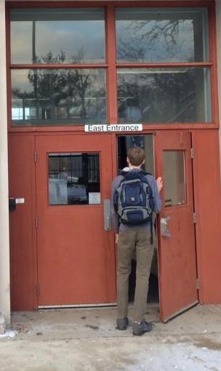
The entrance door of the school. The difference between our idea and the reference image is that our door has opaque glasses instead of transparent ones.
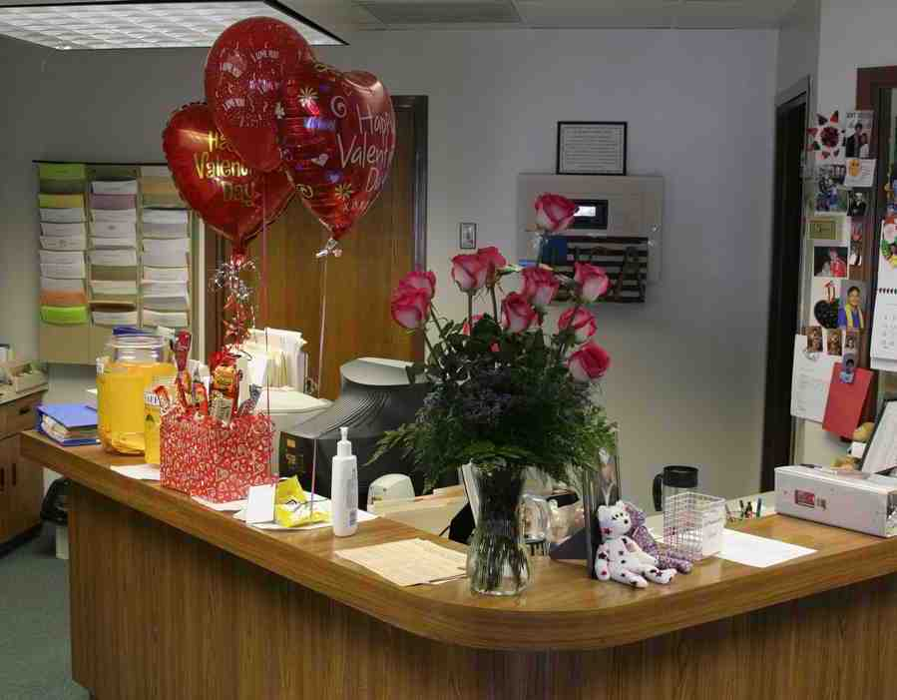
Acceptance desk at the end of the entrance corridor. Even though it’s not clear in the image, in our idea it should have an L-shape. It should also be less chaotic than the on the reference image.

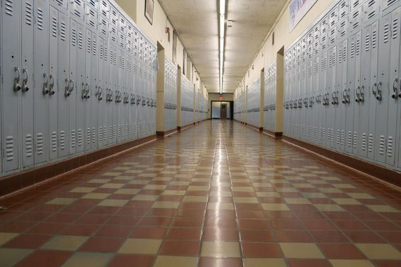
Lockers, walls and floor. Lockers should be placed inside the wall like in the image.
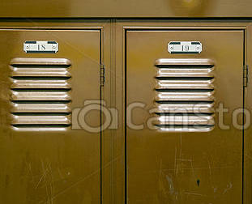
In the lower image locker grates (which are located on the upper and lower part of a locker) are shown in greater details. This image should be a reference only for grates, and not for the lockers.
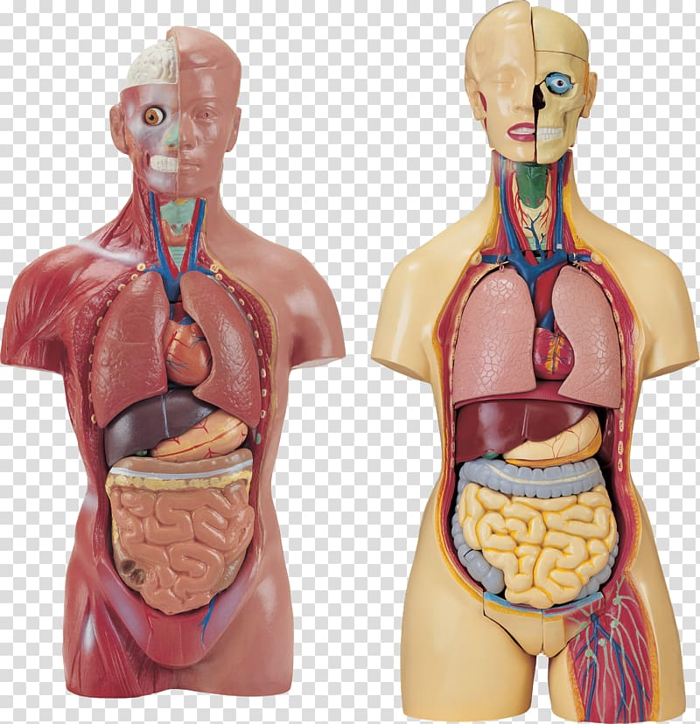
Mannequin examples. These are half body but in the game should be full body.

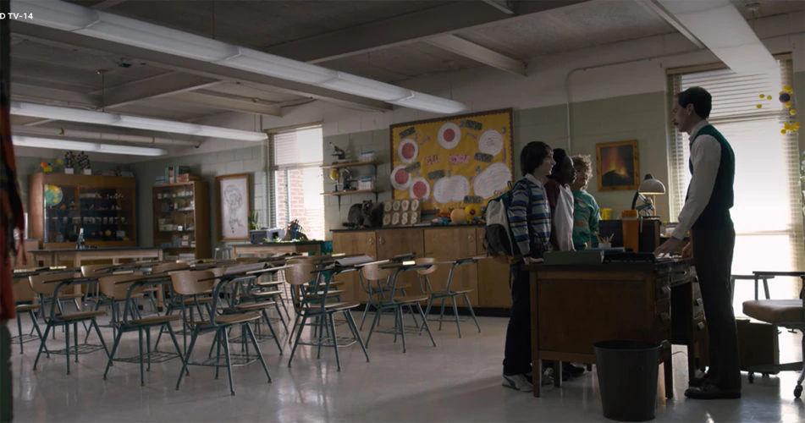
Desks, chairs and general classroom look & feel should match these.
Assets
<waiting for puzzles and collectibles to be decided>
- Planisphere (memory fragment)
- Display case
Lighting
As in the rest of the game, light is soft and the environment lighting tends to darkness. At the beginning of the level, when Eleven shelters inside the school and feels safe, the lighting is more bright than usual. Then, as she crosses the entrance corridor, the light starts shifting to a colder scale and gets back to usual.
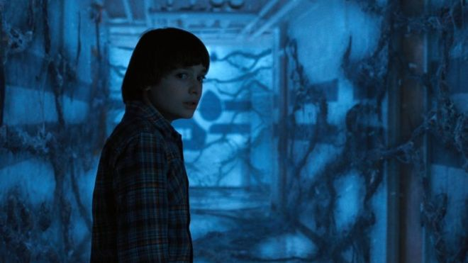
Classic lighting of the Upside Down (picture taken directly from the TV series)
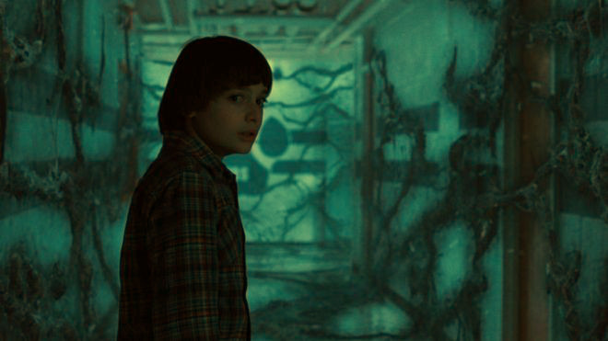
Warmer lighting (colour transformation made through GIMP)
Area 2 – School bottom floor
Description
Environmental description
This area is the bottom floor of Hawkins Middle School. It is approximately x meters long, y meters wide and 2.5 meters high.
The player enters this area through a hole in the floor of the ground floor. At first, they find themselves inside the Boys Locker Room. This room has lockers agains three of the four walls and two benches in the centre. The two benches are distant enough that the player can pass in between.
Near the Boys Locker Room there is, on one side, the Girls Locker Room, and on the other side, the Boiler Room. The Girls Locker Room should be designed in the same way as the Boys Locker Room. For the Boiler Room see the reference images in the following section to get a grasp of the look & feel and see area 2 map to understand its topography.

Colour palette & reference images
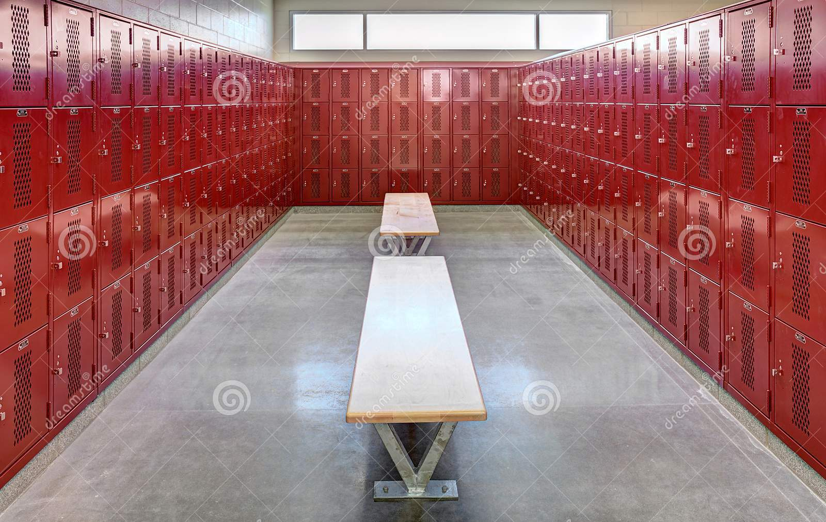
Boys Locker Room.

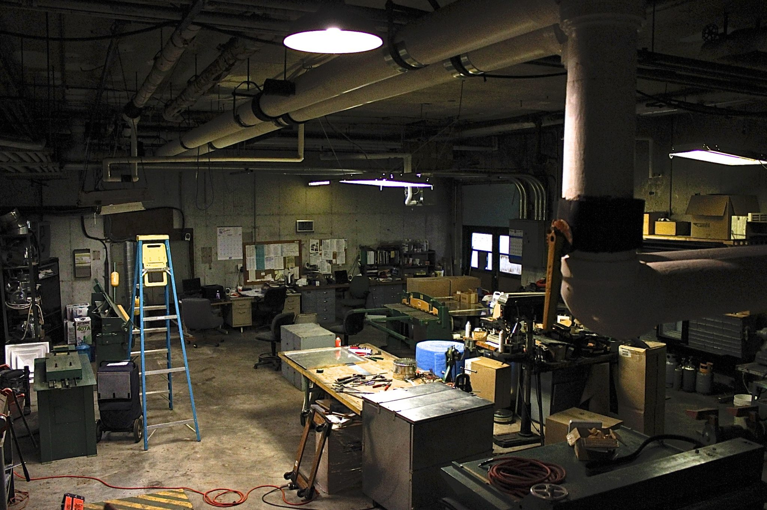
The general look & feel the Boiler Room should have. Pipes contain high-pressure hot steam.

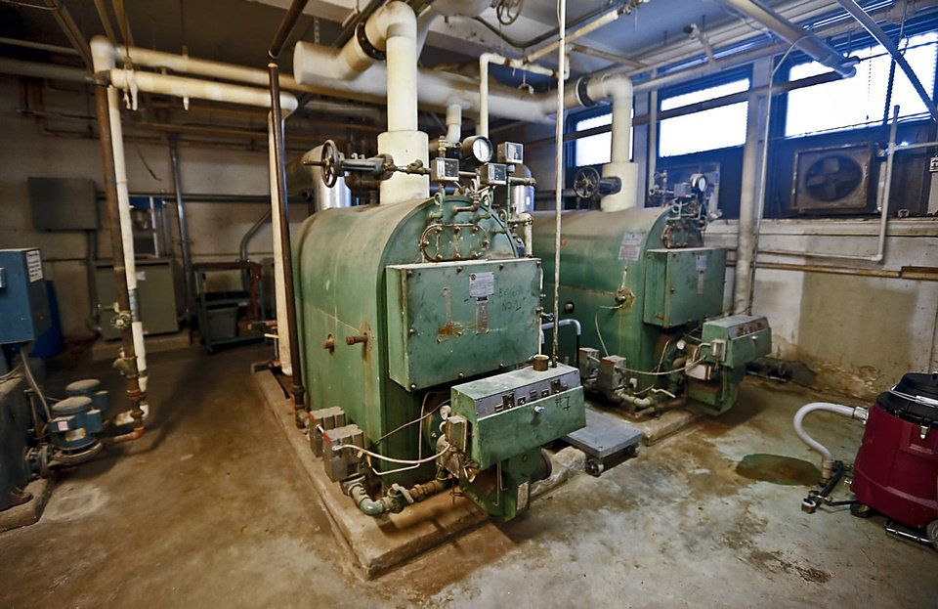
Located somewhere in the Boiler Room there should be machineries similar to these.
Assets
<waiting for puzzles and collectibles to be decided>
- Trophy
- Bolt cutter

Lighting
See Area 1 Lighting.

